**Assignment 2:**

**Building Table Relationships with Excel's Data Model**

Using the **FoodMart_Data_Model**workbook, complete the following steps.

**1)** In **Diagram View** of the data model, use the "**Manage Relationship**" window to delete all existing table relationships

**2)** In **Diagram View**, draw out each relationship to recreate the fully connected data model:

* Connect**Transactions** to **Customer_Lookup**,**Store_Lookup** and **Product_Lookup**
* Connect **Transactions** to **Calendar_Lookup** on both *transaction_date* (***active***) and *stock_date* (***inactive***)
* Connect **Returns** to **Store_Lookup**, **Product_Lookup** and **Calendar_Lookup**
* Connect **Store_Lookup** to **Region_Lookup**

**3)** Try creating a relationship between *Transaction_Date* and *Return_Date*. What happens, and why?

**4)** Hide all foreign key columns in the **Transactions** table using the **Diagram View**, then hide all foreign key columns in the **Returns** table by selecting the column headers in the**Data View**.

**5)** Create a **hierarchy** in the **Product_Lookup** table named *product_set*, containing *product_brand*, *product_name*, and *product_sku* (in that order)

**ANSWERS:**

**1)** *See image below:*

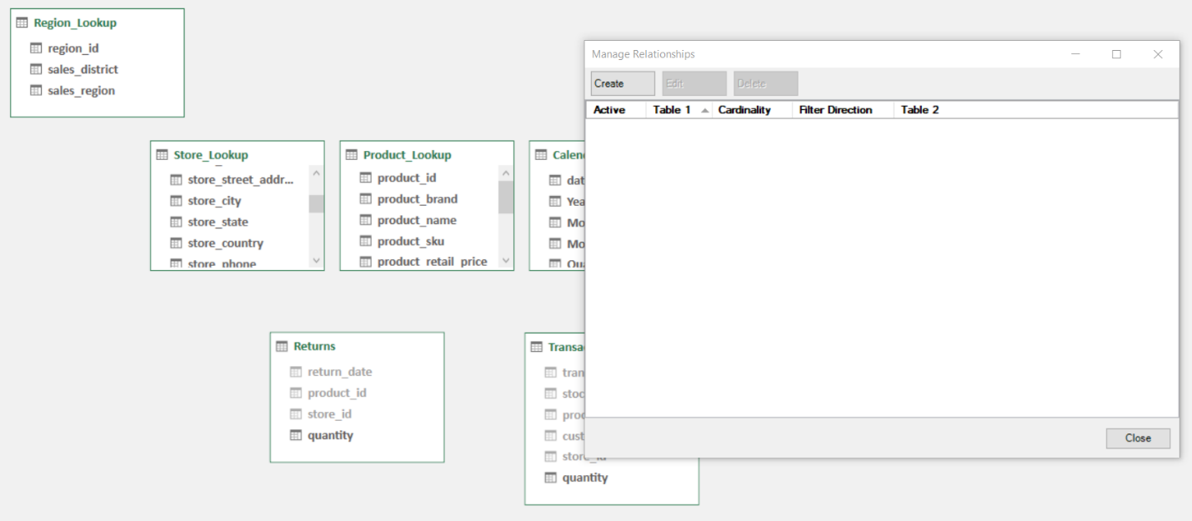

**2)** *See image below:*

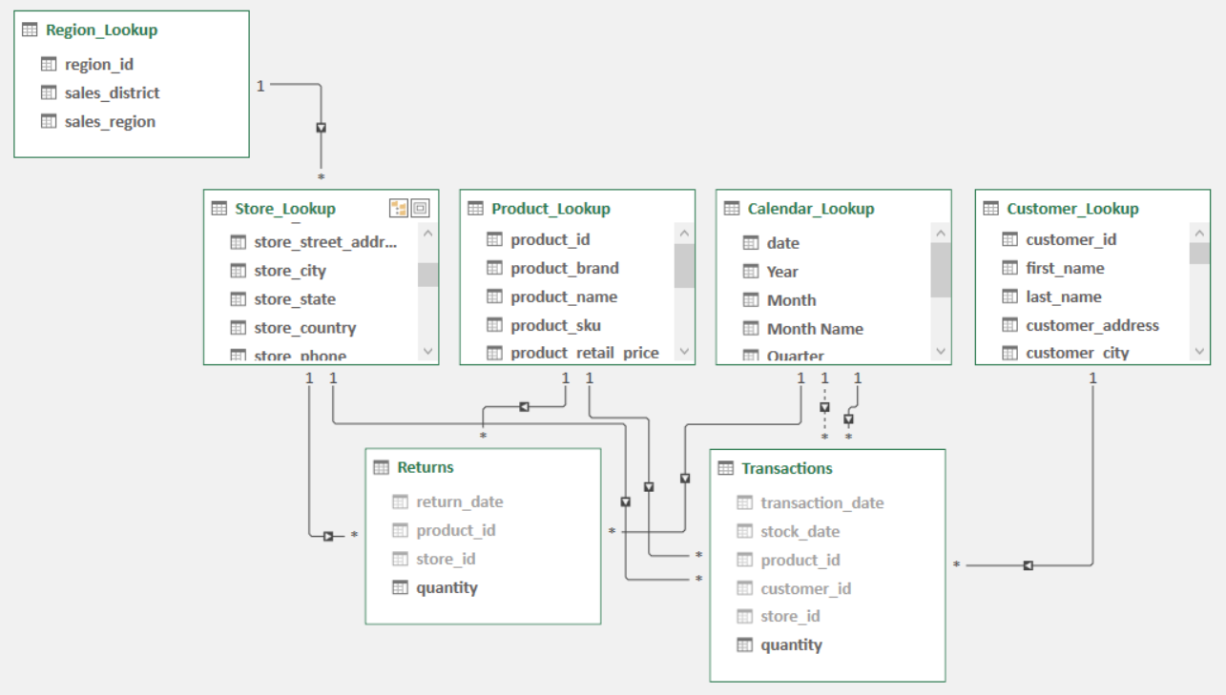

**3)** *The relationship cannot be created because each column contains duplicate values. This represents a "many-to-many" relationship*

**4)** *See image below:*

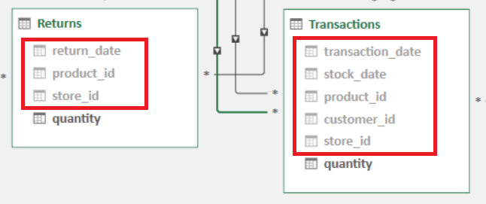

**5)** *See image below:*

